Topic : Library Management System You are going to build a project based on Library Management System. It keeps track of all information about books in the library, their cost, status and total number of books available in the library. Create a database named library and following TABLES in the database: 1. Branch 2. Employee 3. Books 4. Customer 5. IssueStatus 6. ReturnStatus Attributes for the tables: 1. Branch Branch_no - Set as PRIMARY KEY Manager_Id Branch_address Contact_no 2. Employee Emp_Id – Set as PRIMARY KEY Emp_name Position Salary Branch_no - Set as FOREIGN KEY and it refer Branch_no in Branch table 3. Books ISBN - Set as PRIMARY KEY Book_title Category Rental_Price Status [Give yes if book available and no if book not available] Author Publisher 4. Customer Customer_Id - Set as PRIMARY KEY Customer_name Customer_address Reg_date 5. IssueStatus Issue_Id - Set as PRIMARY KEY Issued_cust – Set as FOREIGN KEY and it refer customer_id in CUSTOMER table Issued_book_name Issue_date Isbn_book – Set as FOREIGN KEY and it should refer isbn in BOOKS table 6. ReturnStatus Return_Id - Set as PRIMARY KEY Return_cust Return_book_name Return_date Isbn_book2 - Set as FOREIGN KEY and it should refer isbn in BOOKS table Display all the tables and Write the queries for the following :
- Retrieve the book title, category, and rental price of all available books. 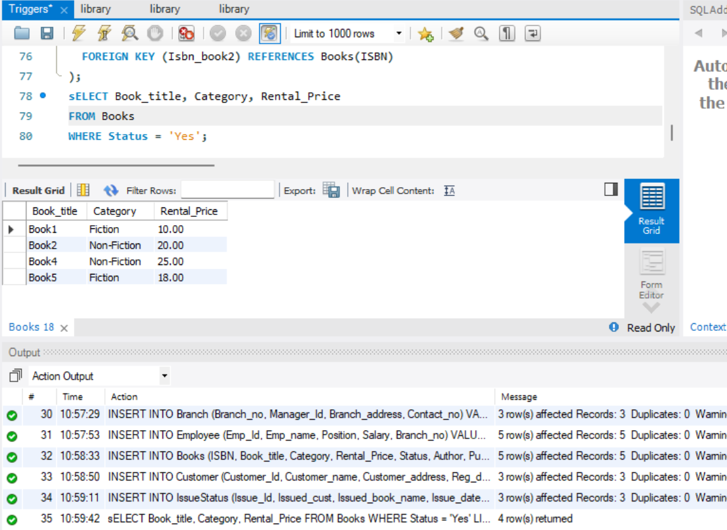
- List the employee names and their respective salaries in descending order of salary.
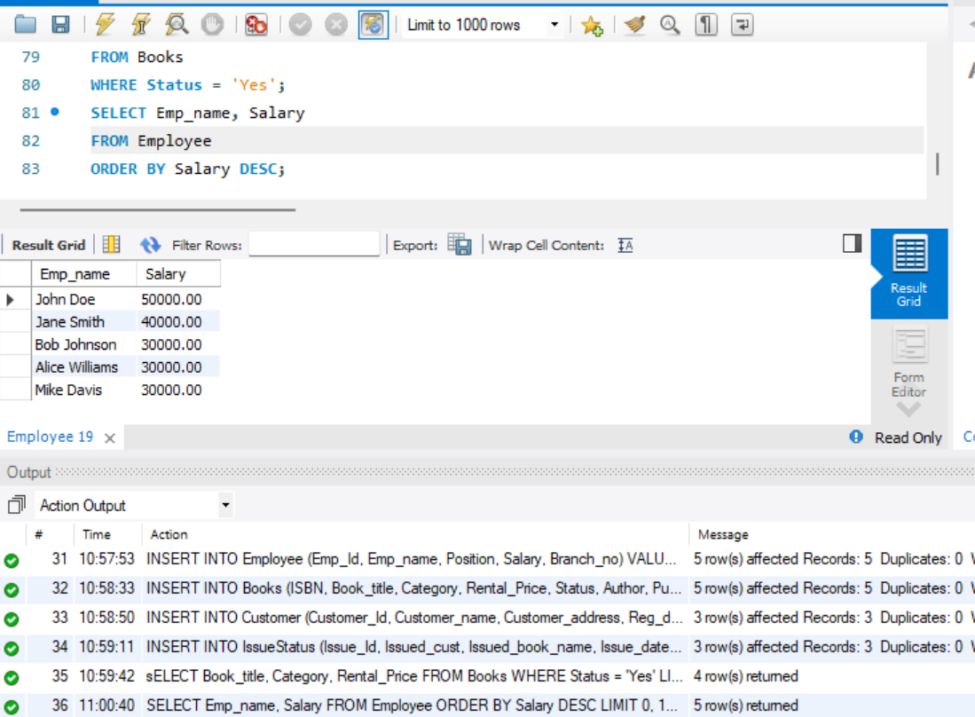
- Retrieve the book titles and the corresponding customers who have issued those books.
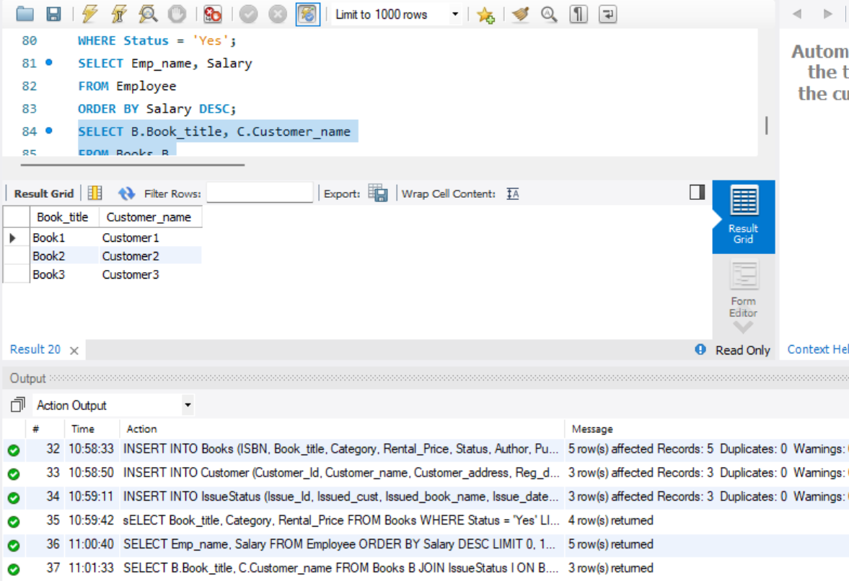
- Display the total count of books in each category.
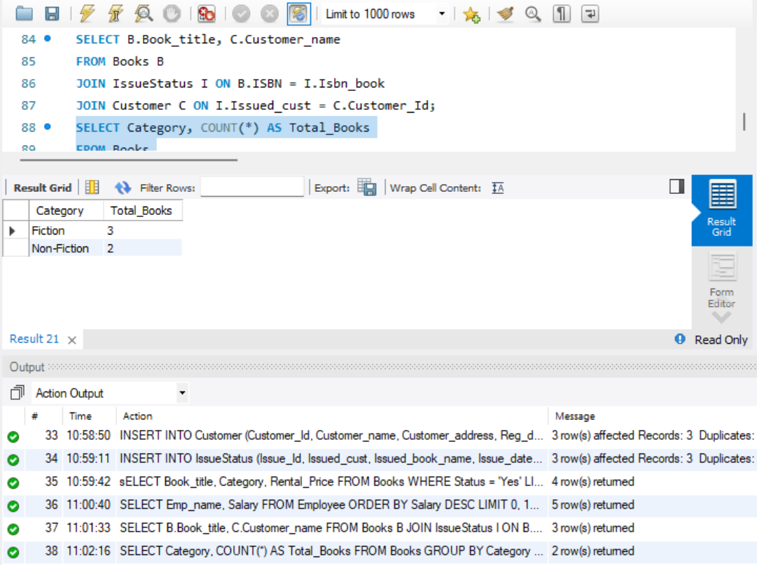
- Retrieve the employee names and their positions for the employees whose salaries are above Rs.50,000.
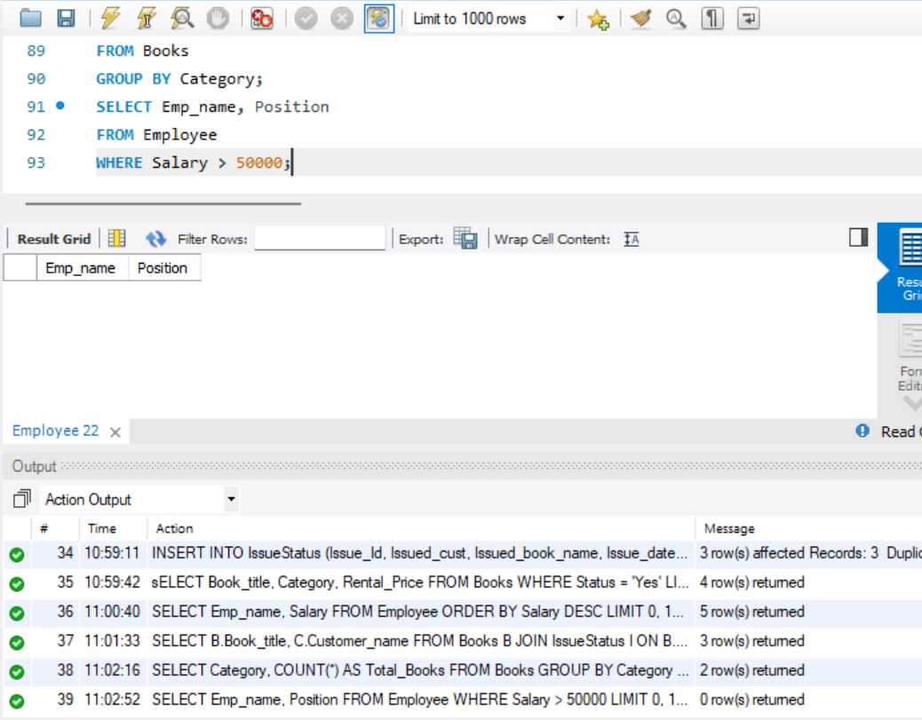
- List the customer names who registered before 2022-01-01 and have not issued any books yet.
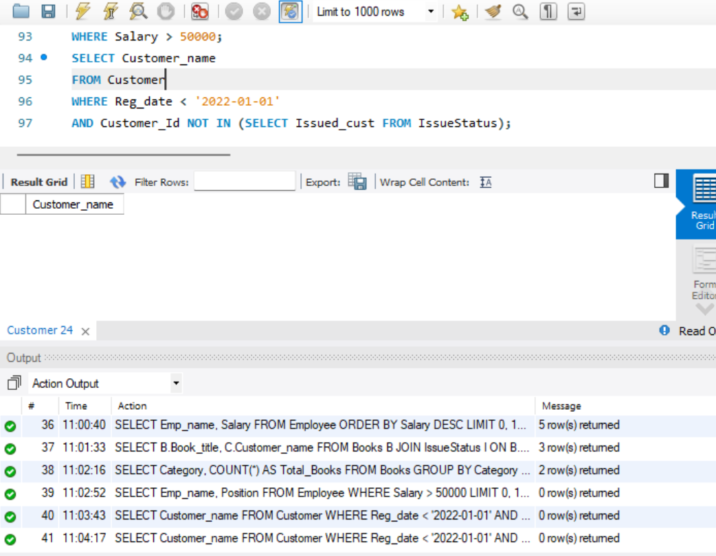
- Display the branch numbers and the total count of employees in each branch.
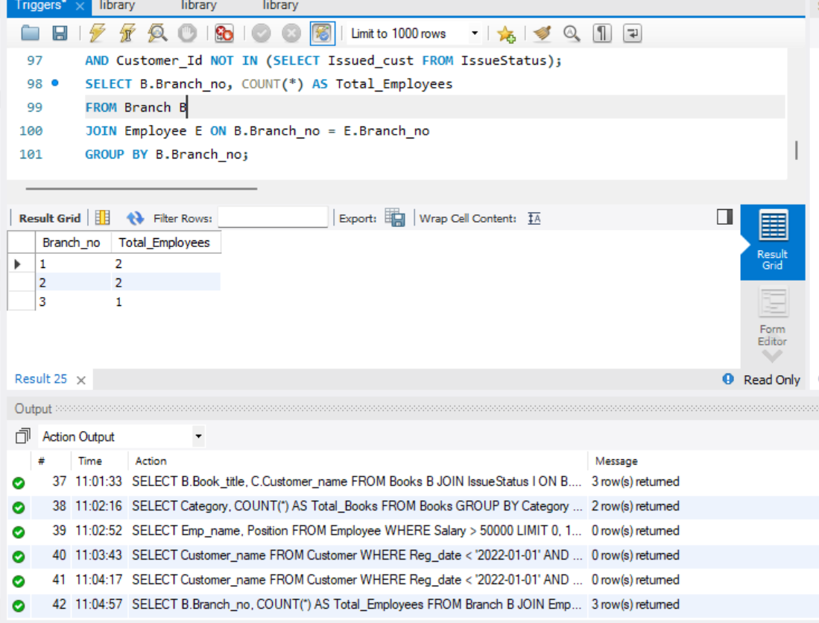
- Display the names of customers who have issued books in the month of June 2023.
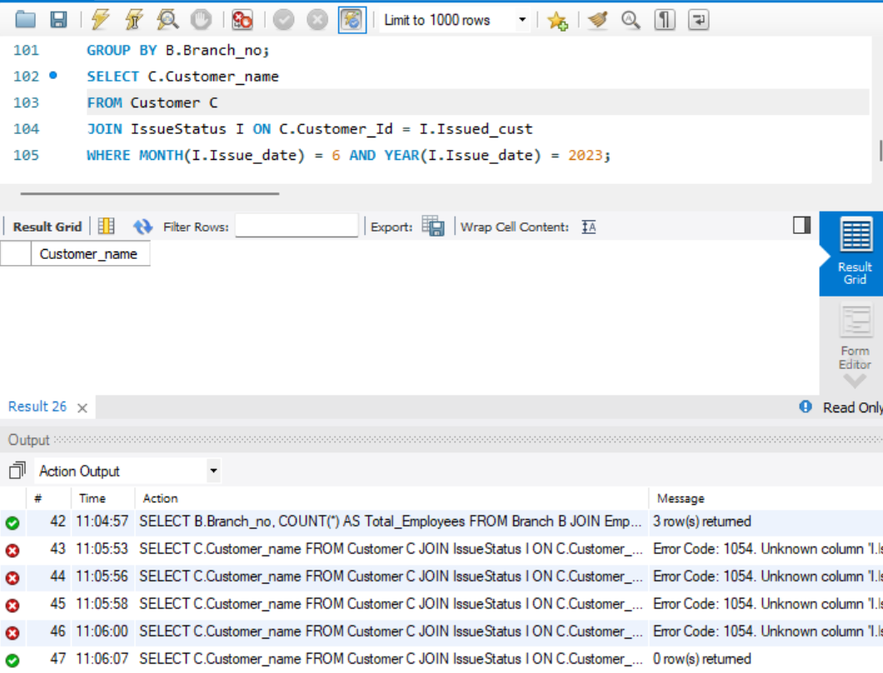
- Retrieve book_title from book table containing history.
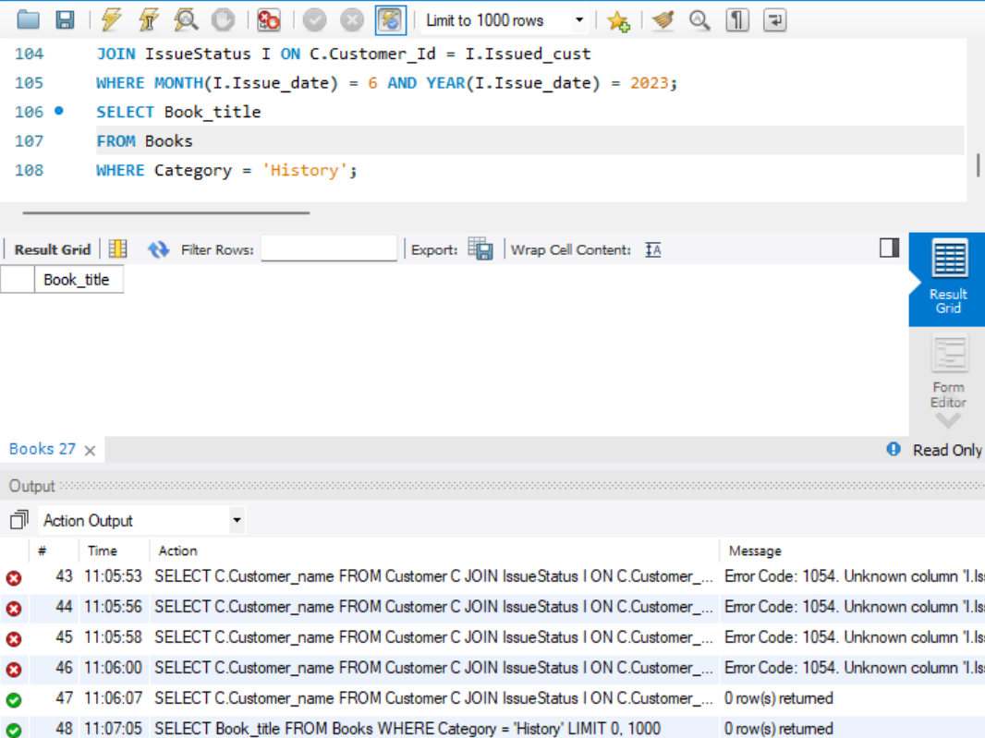
10.Retrieve the branch numbers along with the count of employees for branches having more than 5 employees
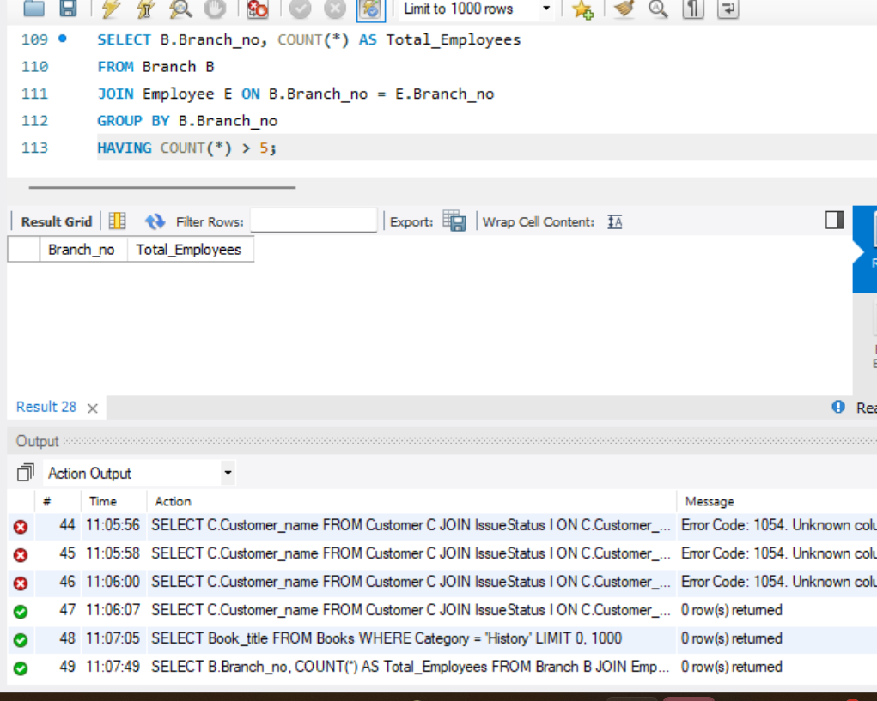
- Retrieve the names of employees who manage branches and their respective branch addresses.
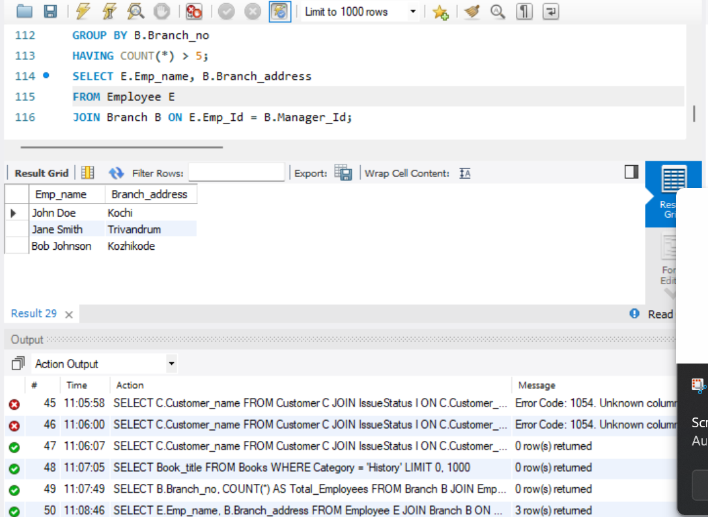
- Display the names of customers who have issued books with a rental price higher than Rs. 25. Score Distribution:
